

**Sunday**

**22/Dec/2012**

**King Fahad University Of Petroleum and Memorials**

**Information and Computer Science Department (ICS)**

**ICS 202 – Project**

ICS 202 Final Project

**Student Name:** Saleh Al‐Ghusson **ID:** 201040340

**Student Name:** Faisal Alsalman **ID:** 201049260

**1.0. Introduction** 3

**2.0. Screen shots** 4

**3.0. Class description and code** 24

3.a Node Class 24

3.b NodeFile Class 24

3.c NodeFolder Class 25

3.d Tree Class 26

3.e Window Class 39

3.a One Class 44

3.b Two Class 46

3.c Three Class 48

3.d Listener Class 50

3.e Stack Class 58

3.a Queue Class 59

3.b Test Class 60

**4.0. *Exception Classes*** 61

4.a GreaterThanMaxException 61

4.b DirectoryDoesNotExist 61

***1) Introduction:***

This project is about managing a windows directory by inserting, deleting and much more methods.

In our project we constructed 20 classes:.

* Node.
* NodeFile.
* NodeFolder.
* Tree
* Window.
* One.
* Two.
* Three
* Listener.
* Stack.
* Queue.
* Test.

Also defined two Exceptions:

* GreaterThanMaxException.
* DirectoryDoesNotExist. In this report the source code will be listed and a brief description will be provided.

***2) Screen shots and their implementations:***

Firstly when the program runs a Java frame will appear showing the options that a user can choose from.

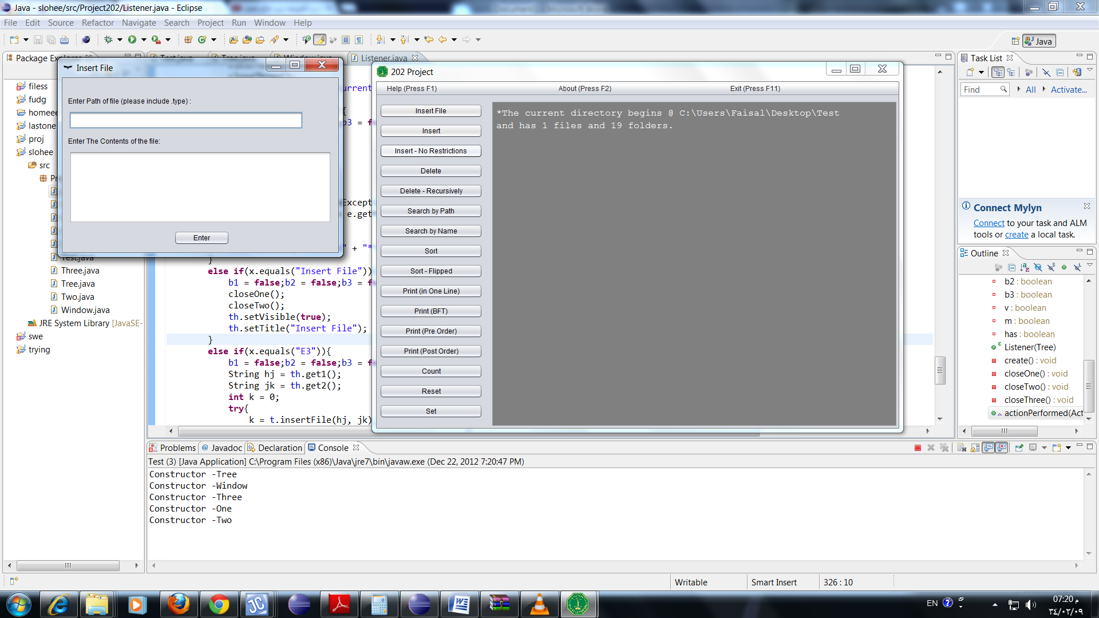

When the user chooses:

**1- Insert File:- (File Only)**

A frame will appear asking the user to write the path to the file he wants to create. The contents of the file, for example as shown:-



The Insert File implementation is in the tree class:-

**protected** **int** **insertFile**(String h, String hj)**throws** GreaterThanMaxException, IOException, FileNotFoundException, DirectoryDoesNotExist{

**int** x = 0;

**if**(!h.contains("\\")){ //path is wrong (to avoid exceptions)

**return** 0;

}

**else** **if**(searchPath(h.substring(0,h.lastIndexOf("\\"))) == **null**){ //direct parent does not exist

**return** 0;

}

**else** **if**(searchPath(h) != **null**){ //direct parent does not exist

x = 1;

}

File f = **new** File(h);

**if**(!f.exists())

f.createNewFile();

PrintWriter out = **new** PrintWriter(**new** BufferedWriter(**new** FileWriter(h, **true**)));

out.println(hj);

out.close();

callScan();

**if**(x == 0)

**return** 2;

**else**

**return** x;

}}

**2- Insert: (Folder only)**

A new frame will appear asking the user to write the path of the parent folder and the path of the folder he wants to add as shown:-

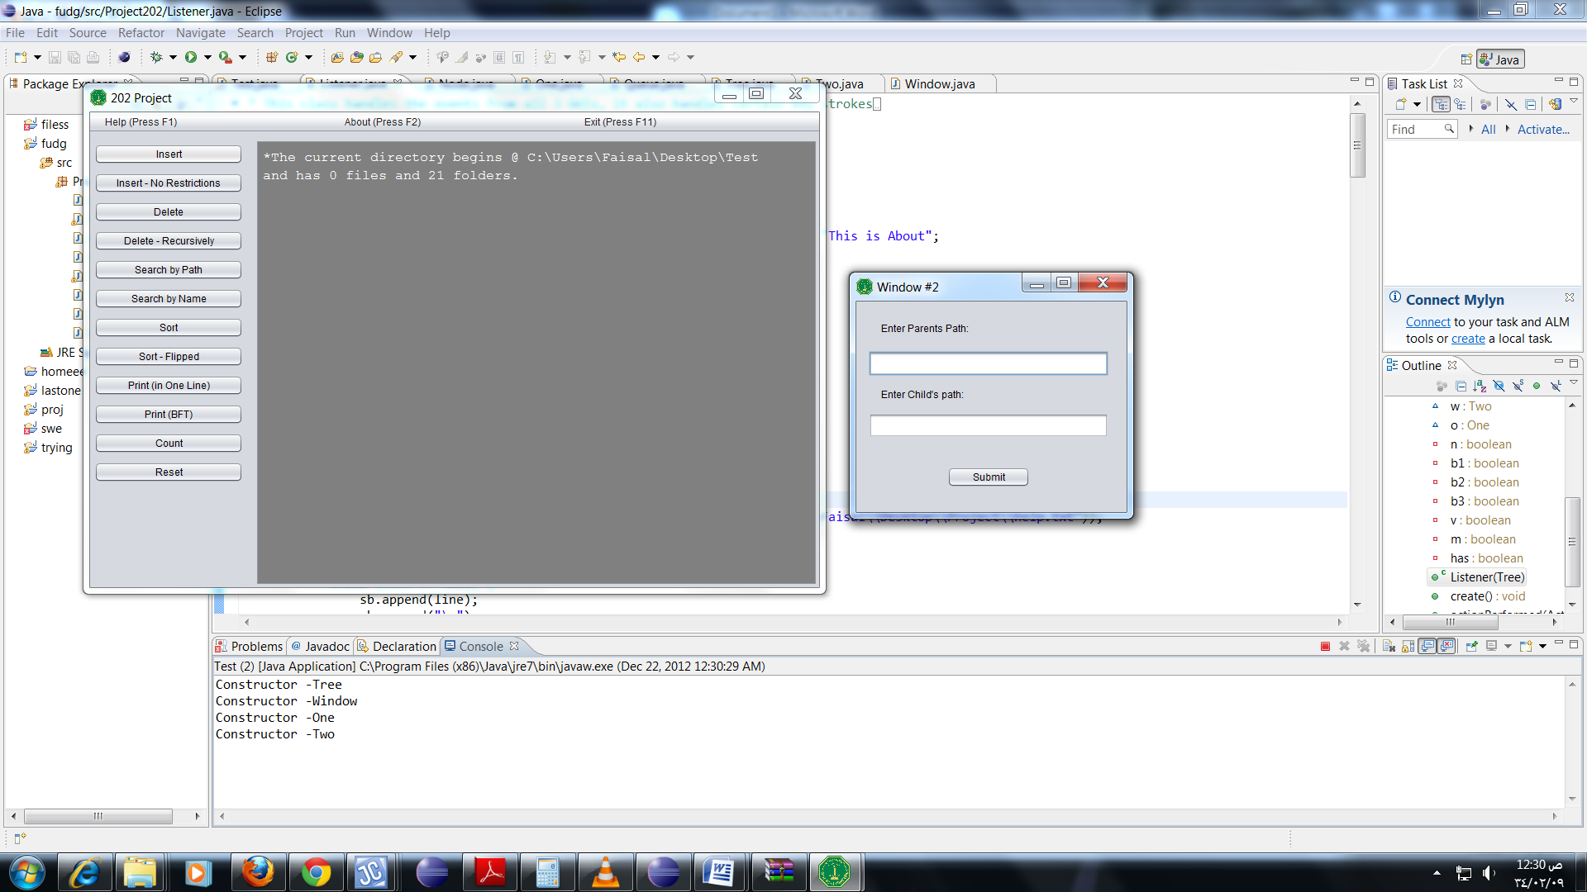

The insert implementation is in the tree class:-

**protected** **boolean** **insert**(String p, String c)**throws** GreaterThanMaxException, DirectoryDoesNotExist{ //restricted

**if**(searchPath(p) == **null**){ //parent does not exist

**return** **false**;

}

**else** **if**(!c.contains(p)){ //child unrelated to parent

**return** **false**;

}

**else** **if**(searchPath(c) != **null** && **new** File(c).isDirectory()){ //child exists

**return** **false**;

}

**boolean** n = **new** File(c).mkdir();

callScan();

**return** n;}}

The method will take two variables, the parent path and the child path. Then will return a boolean true if the insertion was a success, false otherwise.

**3- Insert-No Restrictions:- (Folder only)**

A new frame will appear asking the user to insert the path exactly to where he/she wants to create the new folder as shown:-

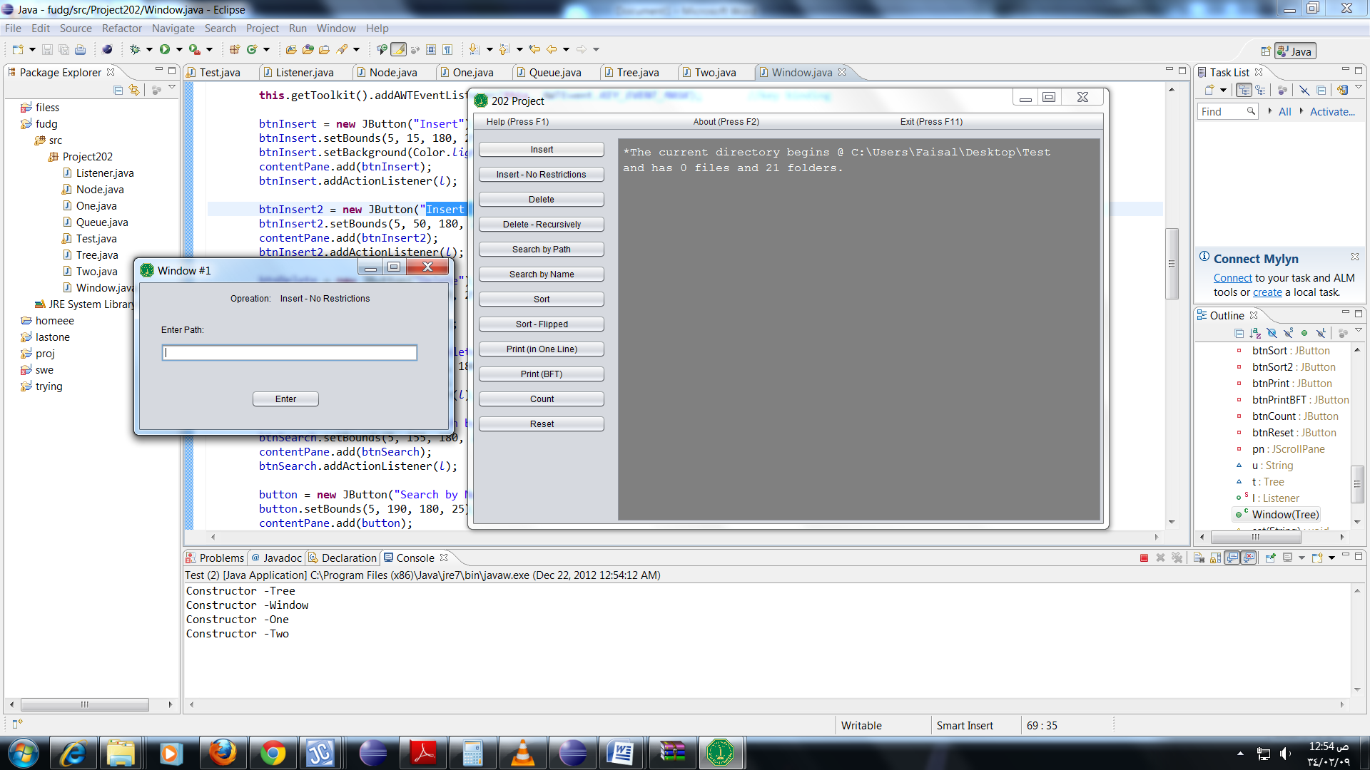

The insertDirect method is in the tree class:-

**protected** **boolean** **insertDirect**(String c)**throws** GreaterThanMaxException, DirectoryDoesNotExist{ //no restrictions

**if**(c.length() < 1 || c.charAt(1) != ':')

**return** **false**;

**if**(!c.contains(root.path))

**return** **false**;

**boolean** n = **new** File(c).mkdirs();

callScan();

**return** n; }

This method will take a complete path to create a new folder. Unlike the previous method, a directory will be created if the direct parent does not exist, this method will automatically create all the needed directories to insert the given directory.

**4- Delete:- (File and Directory)**

A frame will appear asking the user to insert the folder he wants to be deleted by writing its path as shown:-

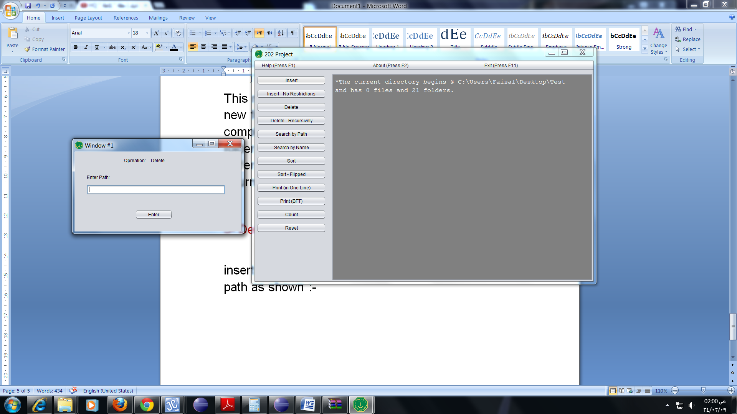

The Delete method is in the tree class:-

**protected** **boolean** **delete**(String h)**throws** GreaterThanMaxException, DirectoryDoesNotExist{

**if**(searchName(h) == **null** && searchPath(h) == **null**)

**return** **false**;

**boolean** n = **new** File(h).delete();

callScan();

**return** n;

}

This method will only delete files and empty directories

**5- Delete -Recursively:-**

A frame will appear asking the user to insert the path of folder to be deleted, and the children of the folder will be deleted too.

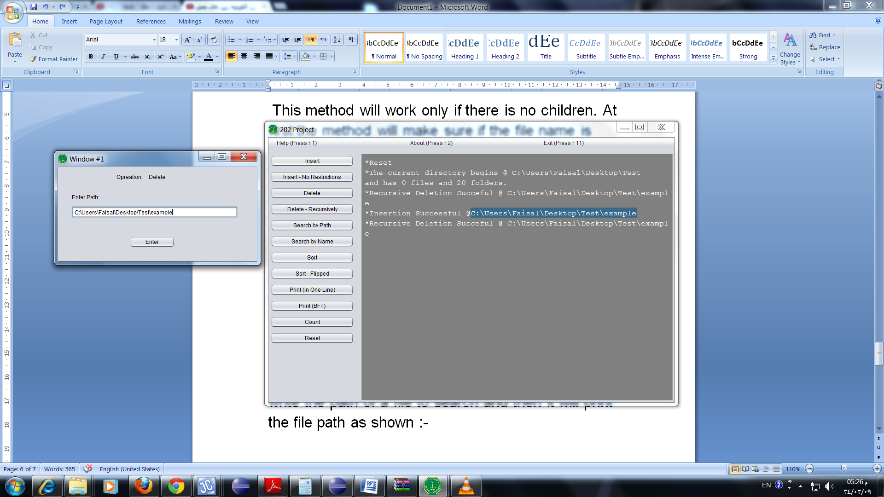

The deleteRec method is in the tree class:-

**protected** **boolean** **deleteRec**(String s)**throws** GreaterThanMaxException, DirectoryDoesNotExist{

**if**(s.length() < 1 || s.charAt(1) != ':')

**return** **false**;

**if**(!s.contains(root.path))

**return** **false**;

File f = **new** File(s);

**if** (f.isDirectory()) {

**for** (File c : f.listFiles())

deleteRec(c.getPath());

}

**if** (!f.delete()){

callScan();

**return** **false**;

}

callScan();

**return** **true**;

}

Unlike the previous method this one will delete directories that are not empty, in addition to all the features of the previous method.

**6- Search by path:-**

A frame will appear asking the user to write the path of a file to search and then it will print the file path as shown:-

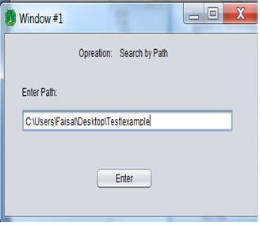 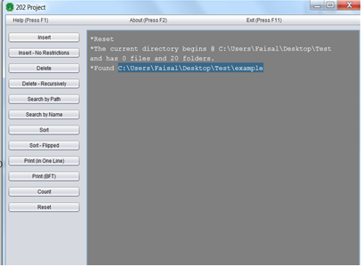

The method searchPath is in the tree class :-

**protected** String **searchPath**(String h){ //works w & w/o .type

String search = h;

**boolean** found = **false**;

Queue<Node> q = **new** Queue<Node>();

Node r;

NodeFolder p;

q.enqueue(root);

**while**(!q.isEmpty() && !found){

r = q.dequeue();

File f = **new** File(r.path);

**if**(f.exists()){

**if**(f.isDirectory()){

p = (NodeFolder) r;

**for**(Node nd : p.children)

q.enqueue(nd);

}

**if**(r.name.contains("."))

**if**(r.path.substring(0, r.path.lastIndexOf('.')).equals(search)){

found = **true**;

search = r.path;

}

**if**(r.path.equals(search)){

found = **true**;

search = r.path;

}

}

}

**if**(found)

**return** search;

**return** **null**;

}

The method will take the path and then store it as a string. It will create a boolean "found" as false and will create queue to insert the elements in it. The it will check and compare if the inserted path does exist the it will return "found" as true.

**7- Search by name:-**

A frame will appear asking the user to write the name of a folder as shown:-

|  |  |
| --- | --- |
|  |  |

The method searchName is in the tree class:-

**protected** String **searchName**(String h){

String search = h; //name w & w/o .type

**boolean** found = **false**;

Queue<Node> q = **new** Queue<Node>();

Node r;

NodeFolder p;

q.enqueue(root);

**while**(! q.isEmpty()){

r = q.dequeue();

File f = **new** File(r.path);

**if**(f.exists()){

**if**(f.isDirectory()){

p = (NodeFolder) r;

**for**(Node nd : p.children)

q.enqueue(nd);

}

**if**(r.name.contains("."))

**if**(r.name.substring(0, r.name.lastIndexOf('.')).equals(search)){

found = **true**;

search = r.path;

}

**if**(r.name.equals(search)){

found = **true**;

search = r.path;

}

}

}

**if**(found)

**return** search;

**return** **null**;

}

Unlike the previous method this only needs the name of the file, and will return it’s path. In case multiple files with the same name exist, the first one encountered will be returned.

**8- Sort:-**

Will sort the tree node by node in alphabetical order.

The method Sort is in the tree class:-

**protected** **void** **sort**(){

Queue<Node> q = **new** Queue<Node>();

Node r;

NodeFolder p;

q.enqueue(root);

**while**(!q.isEmpty()){

r = q.dequeue();

**if**(**new** File(r.path).exists() && **new** File(r.path).isDirectory()){

**int** x = 0;

**if**(**new** File(r.path).list() != **null**)

x = **new** File(r.path).list().length;

p = (NodeFolder) r;

String[] array = **new** String[x];

Node[] tmp = p.children.clone();

**for**(**int** i = 0; i<x; i++){

array[i] = p.children[i].name;

}

Arrays.*sort*(array);

**for**(**int** i = 0; i<x; i++){

**for**(Node nd : tmp)

**if**(nd != **null**)

**if**(nd.name .equals(array[i])){

p.children[i] = nd;

}

}

**for**(Node n: p.children)

q.enqueue(n);

}

}

}

**9- Sort- flipped:-**

Will sort the tree node by node in reverse alphabetical order.

The method SortFlip is in the tree class:-

**protected** **void** **sortFlip**(){

Queue<Node> q = **new** Queue<Node>();

Node r;

NodeFolder p;

q.enqueue(root);

**while**(!q.isEmpty()){

r = q.dequeue();

**if**(**new** File(r.path).exists() && **new** File(r.path).isDirectory()){ //if folder

**int** x = 0;

**if**(**new** File(r.path).list() != **null**)

x = **new** File(r.path).list().length;

p = (NodeFolder) r;

String[] array = **new** String[x];

Node[] tmp = p.children.clone();

**for**(**int** i = 0; i<x; i++){

array[i] = p.children[i].name;

}

Arrays.*sort*(array);

**for**(**int** i = 0; i < array.length/2; i++){ //flip algorithm

String temp = array[i];

array[i] = array[array.length - i - 1];

array[array.length - i - 1] = temp;

}

**for**(**int** i = 0; i<x; i++){

**for**(Node nd : tmp)

**if**(nd != **null**)

**if**(nd.name .equals(array[i])){

p.children[i] = nd;

}

}

**for**(Node n: p.children)

q.enqueue(n);

}

}

}

**10- Print ( in one line) :**

When choosing the print ( in one line ) the program will show the files name in one line in the output screen as shown:-

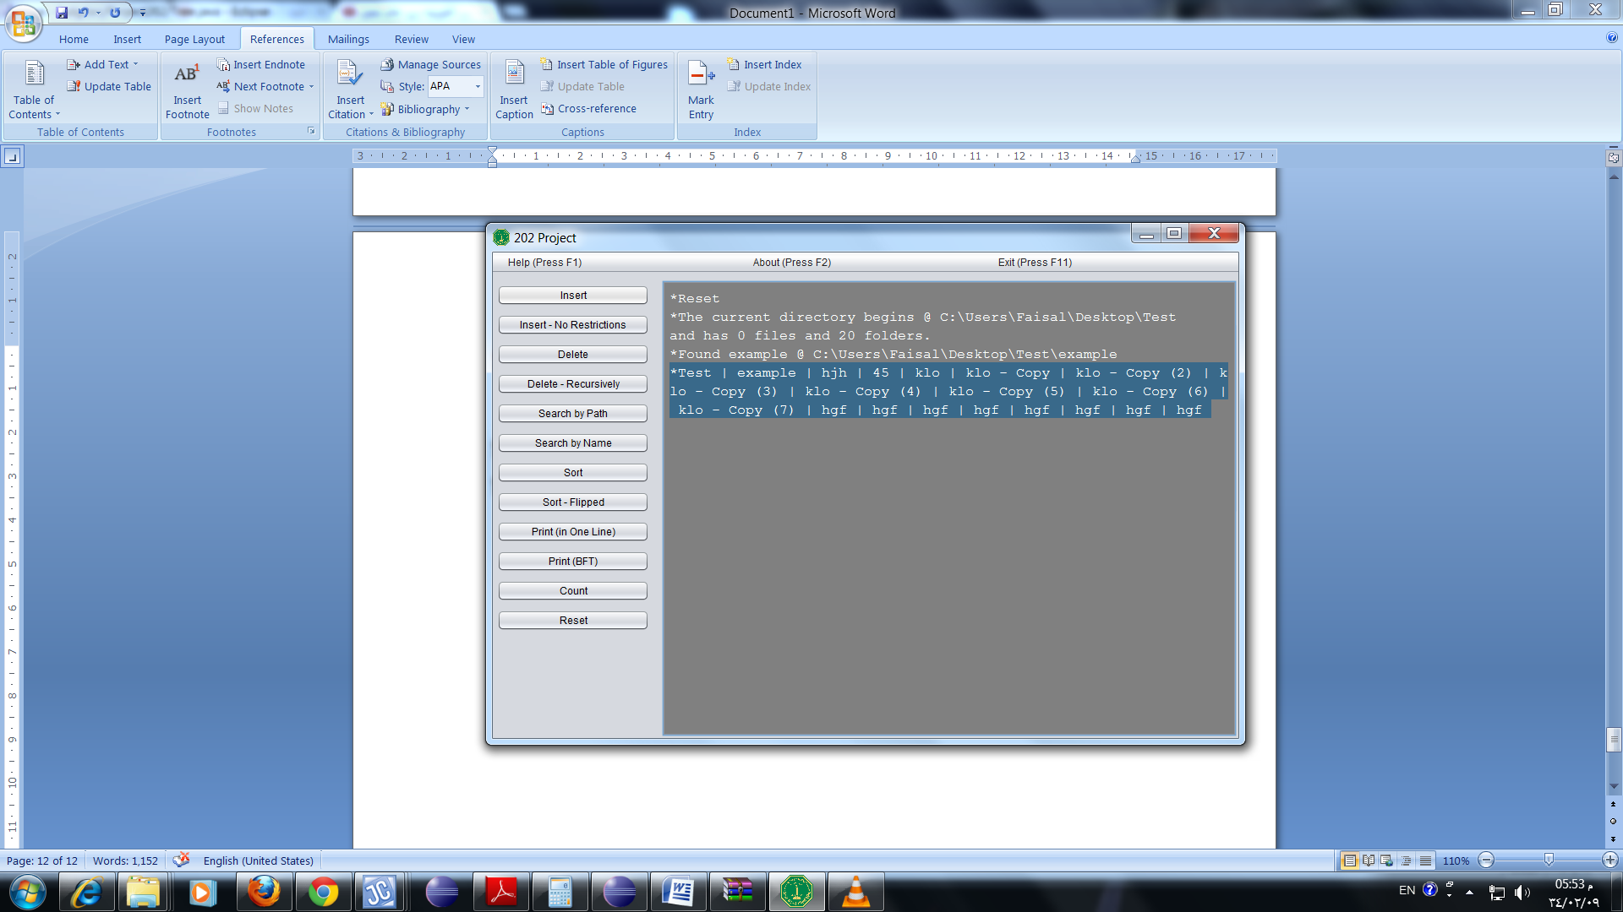

The method Print is in the tree class:-

**protected** String **print**(){

**return** print(root);

}

**protected** String **print**(NodeFolder r){ //in one line

Node f;

Queue<Node> q = **new** Queue<Node>();

String x = **new** String(">");

q.enqueue(r);

**while**(! q.isEmpty()){

f = q.dequeue();

**if**(**new** File(f.path).isFile()){

x+=f.name + " | ";

}

**else** **if**(**new** File(f.path).isDirectory()){

r = (NodeFolder) f;

x+=r.name + " | ";

**for**(**int** i = 0; i<**new** File(f.path).list().length; i++){

q.enqueue(r.children[i]);

}

}

}

**return** x.substring(0, x.lastIndexOf('|'))+"#";

}

**11- PrintBFT:**

Will print the tree in Breadth First Traversal with each level in a new line.

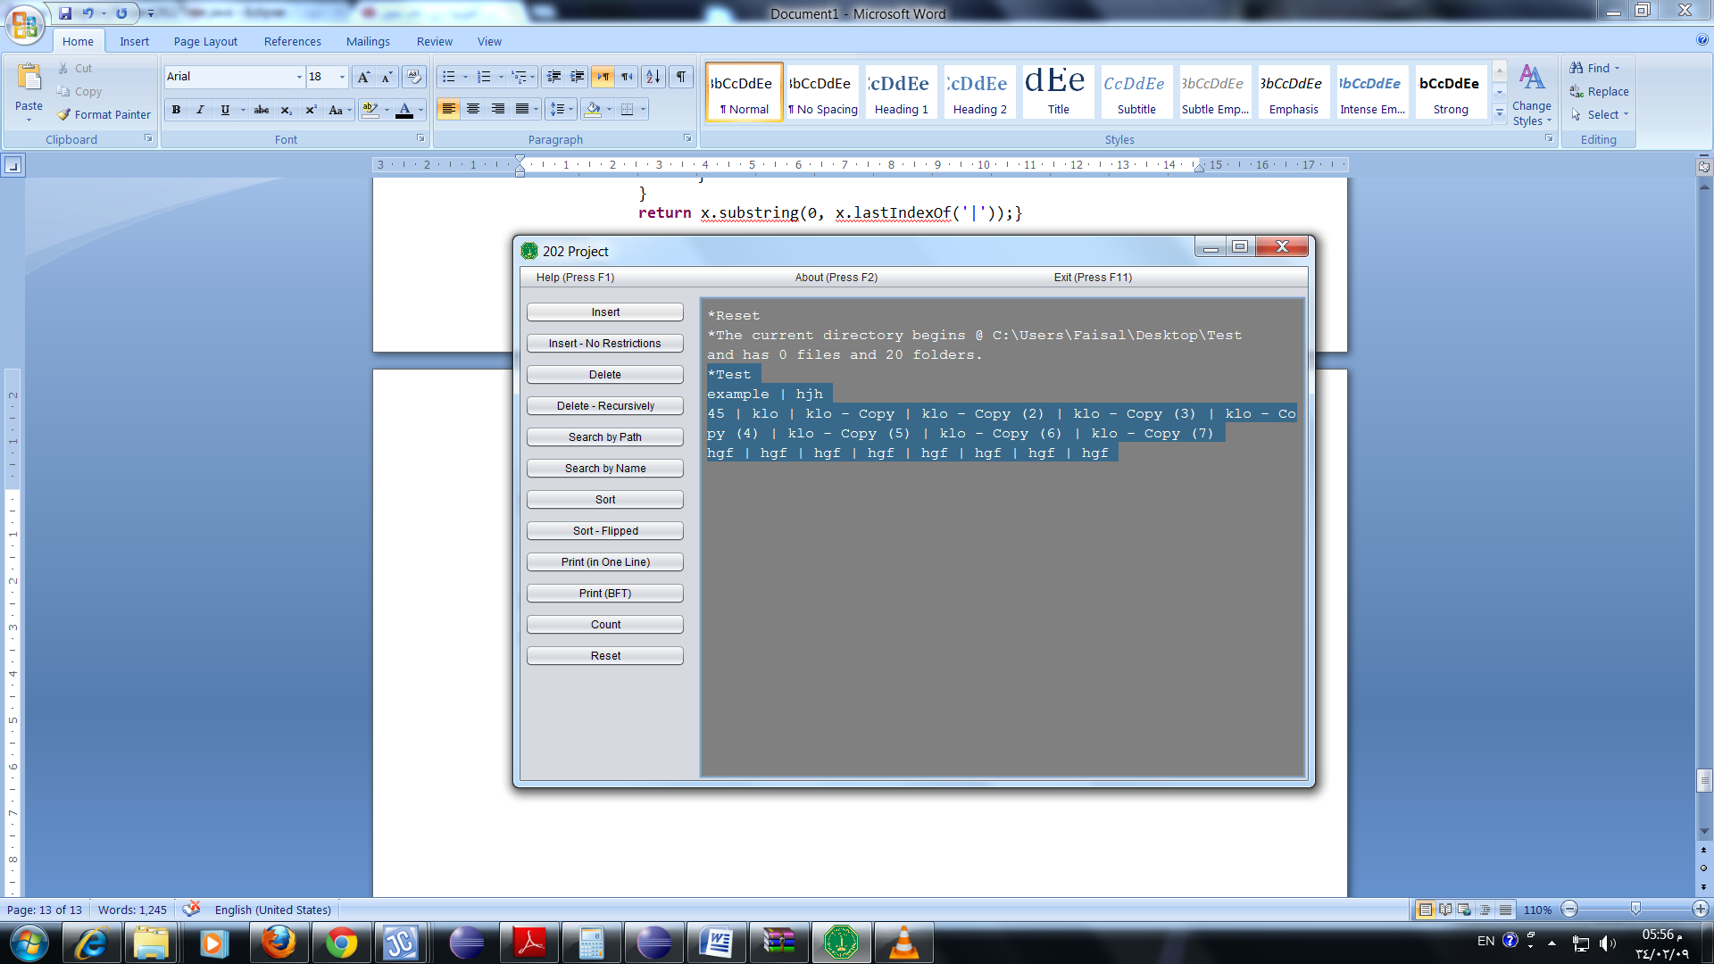

**12- Print(Pre-Order):**

This method is about printing the names of the file in pre-order traversal.

The method Printpre is in the tree class:-

**protected** String **printPre**(){

**return** printPre(root);

}

**protected** String **printPre**(NodeFolder r){ //level by level

Node f;

Stack<Node> s = **new** Stack<Node>();

String x = **new** String(">");

s.push(r);

**while**(! s.isEmpty()){

f = s.pop();

**if**(**new** File(f.path).isFile()){

x+=f.name + " | ";

}

**else** **if**(**new** File(f.path).isDirectory()){

r = (NodeFolder) f;

x+=r.name + " | ";

**for**(**int** i = 0; i<**new** File(f.path).list().length; i++){

s.push(r.children[i]);

}

}

}

**return** x.substring(0, x.lastIndexOf(" |")) + " #";

}

**13- Print(Post-Order) :-**

The method will print it in a Post -order traversal.

The method printPre is in the tree class:-

**protected** String **printPost**(){

**return** printPost(root);

}

**protected** String **printPost**(NodeFolder r){ //level by level

Node f;

Stack<Node> s = **new** Stack<Node>();

String x = **new** String(">");

s.push(r);

**boolean** k = **false**;

**while**(! s.isEmpty()){

f = s.pop();

k = **false**;

**if**(**new** File(f.path).isFile()){

**if**(!f.vis){

f.vis = **true**;

x+=f.name + " | ";

}

}

**else** **if**(**new** File(f.path).isDirectory()){

r = (NodeFolder) f;

**if**(**new** File(r.path).listFiles().length > 0 && !r.vis){

k = **true**;

}

**if**(k){

r.vis = **true**;

s.push(r);

}

**else**

**if**(!r.pr){

r.pr = **true**;

x+=r.name + " | ";

}

**for**(**int** i = 0; i<**new** File(f.path).list().length; i++){

s.push(r.children[i]);

}

}

}

**return** x.substring(0, x.lastIndexOf(" |")) + " #";

}

**14- Count:-**

This method will count the numbers of files and folders in the root and thin print it in the output screen as shown

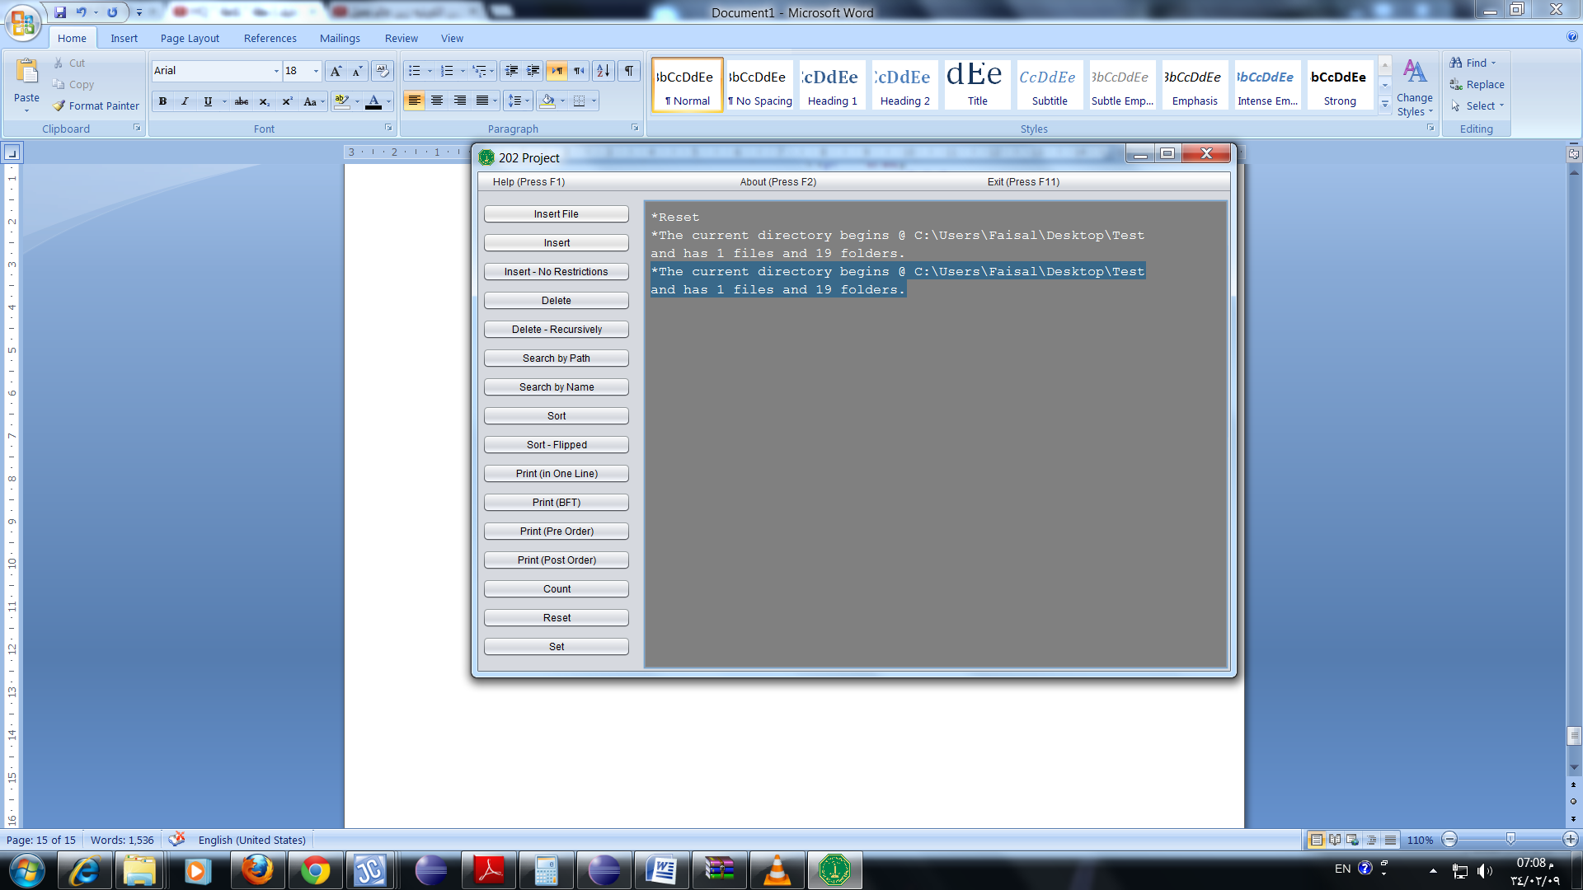

The method is in the tree class :-

**protected** String **count**(){ //includes folder

root.files = countFiles(root);

root.folders = countFolders(root);

**return** root.files + " files and " + root.folders +" folders." ;

}

**private** **int** **countFiles**(NodeFolder r){

Queue<Node> q = **new** Queue<Node>();

Node t;

**int** d=0;

File f = **new** File(r.path);

q.enqueue(r);

**while**(!q.isEmpty()){

t = q.dequeue();

f = **new** File(t.path);

**if**(f.isFile()){

d++;

}

**else** **if**(f.isDirectory()){

String[] a = f.list();

**int** u = a.length;

r = (NodeFolder) t;

**for**(**int** i = 0; i<u; i++){

// if(r.children[i] != nnnn)

q.enqueue(r.children[i]);

}

}

}

**return** d;

}

**private** **int** **countFolders**(NodeFolder r){

Queue<Node> q = **new** Queue<Node>();

Node t;

**int** d=0;

File f = **new** File(r.path);

q.enqueue(r);

**while**(!q.isEmpty()){

t = q.dequeue();

f = **new** File(t.path);

**if**(f.isFile()){

**continue**;

}

**else** **if**(f.isDirectory()){

d++;

String[] a = f.list();

**int** u = a.length;

r = (NodeFolder) t;

**for**(**int** i = 0; i<u; i++){

// if(r.children[i] != nnnn)

q.enqueue(r.children[i]);

}

}

}

**return** d;

}

When count is called it will call two method countfolder and countfile then it will return and print the number of each.

**15- Reset:-**

When the user select reset the output will delete everything in it the it will print the number of the file and folders and also it will print the path of the folder the user work in as shown:-

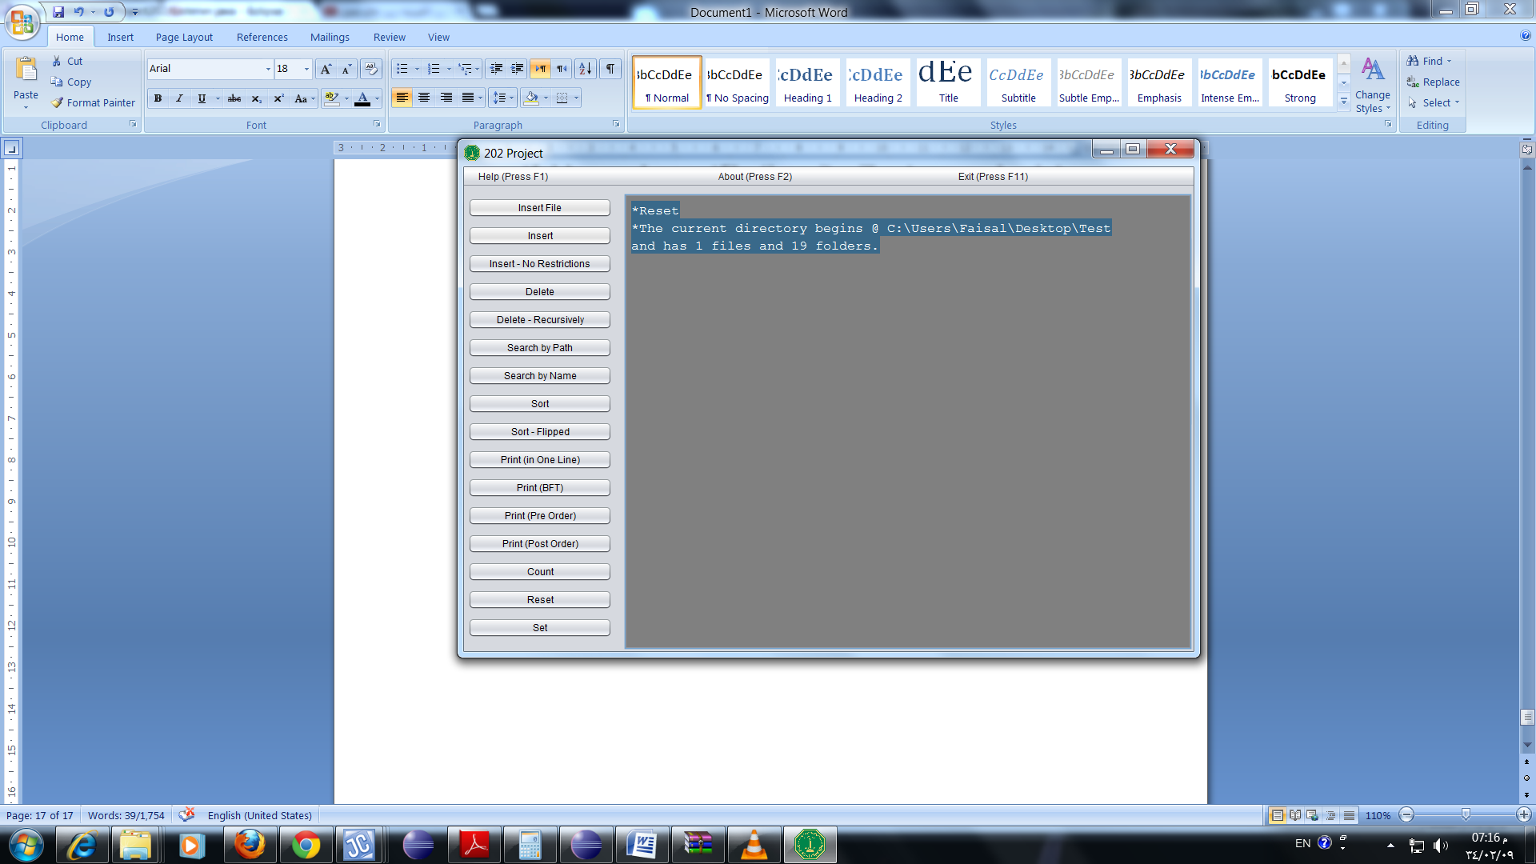

**16- Set:-**

When the user presses set a frame will appear asking the user to write the path of the new file wanted to be work in and then it will print the new file name in the output screen.

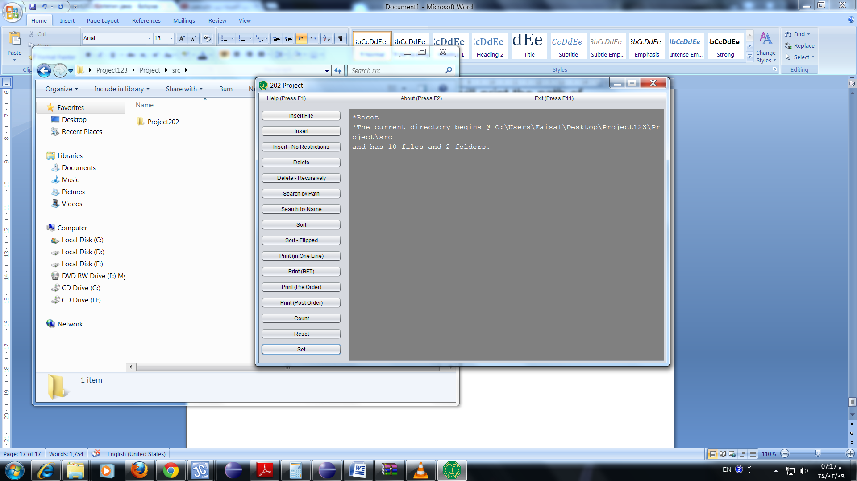

***3) Class description and code:***

**1- Node class:**

**The ancestor to NodeFile and NodeFolder.**

Code:

**public** **class** Node{

String name;

String path; //includes .type

**boolean** vis = **false**;

**public** **Node**(String x, String y){

name = x;

path = y;

}

**public** **Node**(String x){

path = x;

name = x.substring(x.lastIndexOf("\\")+1);

}

}

**2- NodeFile class:**

Code:

**class** NodeFile **extends** Node{

**public** **NodeFile**(String x, String y){

**super**(x,y);

}

}

**3- NodeFolder class:**

Code:

**class** NodeFolder **extends** Node{

Node[] children;

**int** files = -1; //initlize

**int** folders = -1;

**boolean** pr = **false**;

**public** **NodeFolder**(String name, String path, **int** m){

**super**(name,path);

children = **new** Node[m];

}

**public** **NodeFolder**(String path, **int** m){

**super**(path);

children = **new** Node[m];

}

}

**4- Tree:**

**This class contains the main implantation of the tree. Also handles all the exceptions from all the program.**

Code:

/*

*

* This is The Main tree class it has all the main methods and also handles all the exceptions

*/

**import** java.io.BufferedReader;

**import** java.io.BufferedWriter;

**import** java.io.File;

**import** java.io.FileNotFoundException;

**import** java.io.FileReader;

**import** java.io.FileWriter;

**import** java.io.IOException;

**import** java.io.PrintWriter;

**import** java.util.Arrays;

**import** javax.swing.JOptionPane;

@SuppressWarnings("serial")

**class** GreaterThanMaxException **extends** Exception{

**public** **GreaterThanMaxException**() { **super**(); }

**public** **GreaterThanMaxException**(String message) { **super**(message); }

**public** **GreaterThanMaxException**(String message, Throwable cause) { **super**(message, cause); }

**public** **GreaterThanMaxException**(Throwable cause) { **super**(cause); }

}

@SuppressWarnings("serial")

**class** DirectoryDoesNotExist **extends** Exception{ //used For Root Only

**public** **DirectoryDoesNotExist**() { **super**(); }

**public** **DirectoryDoesNotExist**(String message) { **super**(message); }

**public** **DirectoryDoesNotExist**(String message, Throwable cause) { **super**(message, cause); }

**public** **DirectoryDoesNotExist**(Throwable cause) { **super**(cause); }

}

**public** **class** Tree {

**protected** **final** **static** **int** MAX = Test.MAX;

NodeFolder root, tmp;

Window window;

String hash;

**public** **Tree**(String x) **throws** IOException{

*prn*("Constructor -Tree");

String y = x.substring(x.lastIndexOf("\\")+1);

File f = **new** File(x);

root = **new** NodeFolder(y, x, MAX);

**if**(!f.exists())

**throw** **new** FileNotFoundException("Folder does not exist");

callScan();

write();

window = **new** Window(**this**);

}

**protected** **boolean** **change**(){

**try** {

write();

**return** check();

}**catch** (IOException e) {

*error*(e);

}

**return** **false**;

}

**private** **void** **write**() **throws** IOException{

String tmp = print();

tmp = ""+tmp.hashCode();

PrintWriter out = **new** PrintWriter(**new** BufferedWriter(**new** FileWriter(Test.content, **false**)));

out.println(tmp);

out.close();

}

**private** **boolean** **check**() **throws** IOException{

String n = **null**, m = **null**;

BufferedReader br = **new** BufferedReader(**new** FileReader(Test.content));

StringBuilder sb = **new** StringBuilder();

String line = br.readLine();

**while** (line != **null**) {

sb.append(line);

sb.append("\n");

line = br.readLine();

}

n = sb.toString();

br.close();

callScan();

m = ""+print().hashCode();

m = m.trim();

n = n.trim();

**return** n.equals(m);

}

**protected** **static** **void** **prn**(String s){ //to minimise typing

System.out.println(s);

}

**protected** **void** **callScan**(){

**try** {

scan();

}**catch**(GreaterThanMaxException | DirectoryDoesNotExist | IOException e) {

*error*(e);

}

}

**private** **void** **scan**()**throws** GreaterThanMaxException, DirectoryDoesNotExist, IOException{

File f = **new** File(root.path);

String[] x = f.list(); //names of children

**int** j = 0;

Queue<Node> q = **new** Queue<Node>();

File tmp;

Node r;

NodeFolder p;

**if**(!f.exists())

**throw** **new** DirectoryDoesNotExist();

q.enqueue(root);

**while**(! q.isEmpty()){

r = q.dequeue();

f = **new** File(r.path);

x = f.list();

**if**(x != **null**)

**if**(x.length >= MAX)

**throw** **new** GreaterThanMaxException("Directory has greater than max");

**if**(f.isDirectory()){

p = (NodeFolder) r;

**for**(j=0; j<x.length; j++){

tmp = **new** File(p.path+"\\"+x[j]);

**if**(tmp.isFile()){

p.children[j] = **new** NodeFile(x[j], p.path+"\\"+x[j]);

}

**else** **if**(tmp.isDirectory()){

p.children[j] = **new** NodeFolder(x[j], p.path+"\\"+x[j], MAX);

}

q.enqueue(p.children[j]);

}

}

}

write();

count();

}

**protected** **boolean** **setPath**(String h) **throws** GreaterThanMaxException, DirectoryDoesNotExist{

File f = **new** File(h);

**if**(!f.exists() || ! f.isDirectory())

**return** **false**;

root = **new** NodeFolder(h, MAX);

callScan();

**return** **true**;

}

**protected** String **print**(){

**return** print(root);

}

**protected** String **print**(NodeFolder r){ //in one line

Node f;

Queue<Node> q = **new** Queue<Node>();

String x = **new** String(">");

q.enqueue(r);

**while**(! q.isEmpty()){

f = q.dequeue();

**if**(**new** File(f.path).isFile()){

x+=f.name + " | ";

}

**else** **if**(**new** File(f.path).isDirectory()){

r = (NodeFolder) f;

x+=r.name + " | ";

**for**(**int** i = 0; i<**new** File(f.path).list().length; i++){

q.enqueue(r.children[i]);

}

}

}

**return** x.substring(0, x.lastIndexOf('|'))+"#";

}

**protected** String **printBFT**(){

**return** printBFT(root);

}

**protected** String **printBFT**(NodeFolder r){ //level by level

Node f;

Queue<Node> q = **new** Queue<Node>();

String x = **new** String(">");

q.enqueue(r);

**int** scap = 0;

**int** tmp = 0;

String orig = root.path;

**char**[] ch = **new** **char**[1000];

ch = orig.toCharArray();

**for**(**char** v: ch) //algorithm to decide when to create a new line

**if**(v == '\\')

scap++;

tmp = 0;

**while**(! q.isEmpty()){

f = q.dequeue();

orig = f.path;

ch = orig.toCharArray();

tmp = scap;

scap = 0;

**for**(**char** v: ch){

**if**(v == '\\')

scap++;

}

**if**(scap > tmp){

x = x.substring(0, x.lastIndexOf(" |")) + " #\n>"; //remove last '|' before line break

}

**if**(**new** File(f.path).isFile()){

x+=f.name + " | ";

}

**else** **if**(**new** File(f.path).isDirectory()){

r = (NodeFolder) f;

x+=r.name + " | ";

**for**(**int** i = 0; i<**new** File(f.path).list().length; i++){

q.enqueue(r.children[i]);

}

}

}

**return** x.substring(0, x.lastIndexOf(" |")) + " #";

}

**protected** String **printPre**(){

**return** printPre(root);

}

**protected** String **printPre**(NodeFolder r){ //level by level

Node f;

Stack<Node> s = **new** Stack<Node>();

String x = **new** String(">");

s.push(r);

**while**(! s.isEmpty()){

f = s.pop();

**if**(**new** File(f.path).isFile()){

x+=f.name + " | ";

}

**else** **if**(**new** File(f.path).isDirectory()){

r = (NodeFolder) f;

x+=r.name + " | ";

**for**(**int** i = 0; i<**new** File(f.path).list().length; i++){

s.push(r.children[i]);

}

}

}

**return** x.substring(0, x.lastIndexOf(" |")) + " #";

}

**protected** String **printPost**(){

**return** printPost(root);

}

**protected** String **printPost**(NodeFolder r){ //level by level

Node f;

Stack<Node> s = **new** Stack<Node>();

String x = **new** String(">");

s.push(r);

**boolean** k = **false**;

**while**(! s.isEmpty()){

f = s.pop();

k = **false**;

**if**(**new** File(f.path).isFile()){

**if**(!f.vis){

f.vis = **true**;

x+=f.name + " | ";

}

}

**else** **if**(**new** File(f.path).isDirectory()){

r = (NodeFolder) f;

**if**(**new** File(r.path).listFiles().length > 0 && !r.vis){

k = **true**;

}

**if**(k){

r.vis = **true**;

s.push(r);

}

**else**

**if**(!r.pr){

r.pr = **true**;

x+=r.name + " | ";

}

**for**(**int** i = 0; i<**new** File(f.path).list().length; i++){

s.push(r.children[i]);

}

}

}

**return** x.substring(0, x.lastIndexOf(" |")) + " #";

}

**protected** String **count**(){ //includes folder

root.files = countFiles(root);

root.folders = countFolders(root);

**return** root.files + " files and " + root.folders +" folders." ;

}

**private** **int** **countFiles**(NodeFolder r){

Queue<Node> q = **new** Queue<Node>();

Node t;

**int** d=0;

File f = **new** File(r.path);

q.enqueue(r);

**while**(!q.isEmpty()){

t = q.dequeue();

f = **new** File(t.path);

**if**(f.isFile()){

d++;

}

**else** **if**(f.isDirectory()){

String[] a = f.list();

**int** u = a.length;

r = (NodeFolder) t;

**for**(**int** i = 0; i<u; i++){

// if(r.children[i] != nnnn)

q.enqueue(r.children[i]);

}

}

}

**return** d;

}

**private** **int** **countFolders**(NodeFolder r){

Queue<Node> q = **new** Queue<Node>();

Node t;

**int** d=0;

File f = **new** File(r.path);

q.enqueue(r);

**while**(!q.isEmpty()){

t = q.dequeue();

f = **new** File(t.path);

**if**(f.isFile()){

**continue**;

}

**else** **if**(f.isDirectory()){

d++;

String[] a = f.list();

**int** u = a.length;

r = (NodeFolder) t;

**for**(**int** i = 0; i<u; i++){

q.enqueue(r.children[i]);

}

}

}

**return** d;

}

**protected** String **getParentPath**(Node p){ //never used

String x = p.path.substring(0, p.path.lastIndexOf("\\"));

**if**(x.contains(root.path)){

**return** p.path.substring(0, p.path.lastIndexOf("\\"));

}

**return** **null**;

}

**protected** String **searchPath**(String h){ //works w & w/o .type

String search = h;

**boolean** found = **false**;

Queue<Node> q = **new** Queue<Node>();

Node r;

NodeFolder p;

q.enqueue(root);

**while**(!q.isEmpty() && !found){

r = q.dequeue();

File f = **new** File(r.path);

**if**(f.exists()){

**if**(f.isDirectory()){

p = (NodeFolder) r;

**for**(Node nd : p.children)

q.enqueue(nd);

}

**if**(r.name.contains("."))

**if**(r.path.substring(0, r.path.lastIndexOf('.')).equals(search)){

found = **true**;

search = r.path;

}

**if**(r.path.equals(search)){

found = **true**;

search = r.path;

}

}

}

**if**(found)

**return** search;

**return** **null**;

}

**protected** String **searchName**(String h){

String search = h; //name w & w/o .type

**boolean** found = **false**;

Queue<Node> q = **new** Queue<Node>();

Node r;

NodeFolder p;

q.enqueue(root);

**while**(! q.isEmpty()){

r = q.dequeue();

File f = **new** File(r.path);

**if**(f.exists()){

**if**(f.isDirectory()){

p = (NodeFolder) r;

**for**(Node nd : p.children)

q.enqueue(nd);

}

**if**(r.name.contains("."))

**if**(r.name.substring(0, r.name.lastIndexOf('.')).equals(search)){

found = **true**;

search = r.path;

}

**if**(r.name.equals(search)){

found = **true**;

search = r.path;

}

}

}

**if**(found)

**return** search;

**return** **null**;

}

**protected** **boolean** **insert**(String p, String c)**throws** GreaterThanMaxException, DirectoryDoesNotExist{ //restricted

**if**(searchPath(p) == **null**){ //parent does not exist

**return** **false**;

}

**else** **if**(!c.contains(p)){ //child unrelated to parent

**return** **false**;

}

**else** **if**(searchPath(c) != **null** && **new** File(c).isDirectory()){ //child exists

**return** **false**;

}

**boolean** n = **new** File(c).mkdir();

callScan();

**return** n;

}

**protected** **boolean** **insertDirect**(String c)**throws** GreaterThanMaxException, DirectoryDoesNotExist{ //no restrictions

**if**(c.length() < 1 || c.charAt(1) != ':')

**return** **false**;

**if**(!c.contains(root.path))

**return** **false**;

**boolean** n = **new** File(c).mkdirs();

callScan();

**return** n;

}

/*

* if the file exists it will append it

*/

**protected** **int** **insertFile**(String h, String hj)**throws** GreaterThanMaxException, IOException, FileNotFoundException, DirectoryDoesNotExist{

**int** x = 0;

**if**(!h.contains("\\")){ //path is wrong (to avoid exceptions)

**return** 0;

}

**else** **if**(searchPath(h.substring(0,h.lastIndexOf("\\"))) == **null**){ //direct parent does not exist

**return** 0;

}

**else** **if**(searchPath(h) != **null**){ //direct parent does not exist

x = 1;

}

File f = **new** File(h);

**if**(!f.exists())

f.createNewFile();

PrintWriter out = **new** PrintWriter(**new** BufferedWriter(**new** FileWriter(h, **true**)));

out.println(hj);

out.close();

callScan();

**if**(x == 0)

**return** 2;

**else**

**return** x;

}

**protected** **boolean** **delete**(String h)**throws** GreaterThanMaxException, DirectoryDoesNotExist{

**if**(searchName(h) == **null** && searchPath(h) == **null**)

**return** **false**;

**boolean** n = **new** File(h).delete();

callScan();

**return** n;

}

**protected** **boolean** **deleteRec**(String s)**throws** GreaterThanMaxException, DirectoryDoesNotExist{

**if**(s.length() < 1 || s.charAt(1) != ':')

**return** **false**;

**if**(!s.contains(root.path))

**return** **false**;

File f = **new** File(s);

**if** (f.isDirectory()) {

**for** (File c : f.listFiles())

deleteRec(c.getPath());

}

**if** (!f.delete()){

callScan();

**return** **false**;

}

callScan();

**return** **true**;

}

**protected** **void** **sort**(){

Queue<Node> q = **new** Queue<Node>();

Node r;

NodeFolder p;

q.enqueue(root);

**while**(!q.isEmpty()){

r = q.dequeue();

**if**(**new** File(r.path).exists() && **new** File(r.path).isDirectory()){

**int** x = 0;

**if**(**new** File(r.path).list() != **null**)

x = **new** File(r.path).list().length;

p = (NodeFolder) r;

String[] array = **new** String[x];

Node[] tmp = p.children.clone();

**for**(**int** i = 0; i<x; i++){

array[i] = p.children[i].name;

}

Arrays.*sort*(array);

**for**(**int** i = 0; i<x; i++){

**for**(Node nd : tmp)

**if**(nd != **null**)

**if**(nd.name .equals(array[i])){

p.children[i] = nd;

}

}

**for**(Node n: p.children)

q.enqueue(n);

}

}

}

**protected** **void** **sortFlip**(){

Queue<Node> q = **new** Queue<Node>();

Node r;

NodeFolder p;

q.enqueue(root);

**while**(!q.isEmpty()){

r = q.dequeue();

**if**(**new** File(r.path).exists() && **new** File(r.path).isDirectory()){ //if folder

**int** x = 0;

**if**(**new** File(r.path).list() != **null**)

x = **new** File(r.path).list().length;

p = (NodeFolder) r;

String[] array = **new** String[x];

Node[] tmp = p.children.clone();

**for**(**int** i = 0; i<x; i++){

array[i] = p.children[i].name;

}

Arrays.*sort*(array);

**for**(**int** i = 0; i < array.length/2; i++){ //flip algorithm

String temp = array[i];

array[i] = array[array.length - i - 1];

array[array.length - i - 1] = temp;

}

**for**(**int** i = 0; i<x; i++){

**for**(Node nd : tmp)

**if**(nd != **null**)

**if**(nd.name .equals(array[i])){

p.children[i] = nd;

}

}

**for**(Node n: p.children)

q.enqueue(n);

}

}

}

@SuppressWarnings("static-access")

**protected** **static** **void** **error**(Exception e){ //Exception Handling

*prn*("Test. error");

**if**(e **instanceof** GreaterThanMaxException)

**new** JOptionPane().*showMessageDialog*(**null**, "You have Exceeded the limit of " + Tree.MAX + " Objects in a directory\n Program will exit", "Error", JOptionPane.INFORMATION_MESSAGE);

**else** **if**(e **instanceof** DirectoryDoesNotExist)

**new** JOptionPane().*showMessageDialog*(**null**, "The Main Directory Does Not Exist\n Program will exit", "Error", JOptionPane.INFORMATION_MESSAGE);

**else**{

**new** JOptionPane().*showMessageDialog*(**null**, "UnKnown error\n" + e.getMessage(), "Error", JOptionPane.INFORMATION_MESSAGE);

}

e.printStackTrace();

System.*exit*(0);

}

}

**5- Window:-**

**Main GUI.**

Code:

/*

*

* This is the main GUI

*/

**import** javax.swing.JFrame;

**import** javax.swing.JPanel;

**import** javax.swing.border.EmptyBorder;

**import** javax.swing.JButton;

**import** javax.swing.JTextArea;

**import** javax.swing.UIManager;

**import** javax.swing.JMenuBar;

**import** javax.swing.JMenuItem;

**import** javax.swing.JScrollPane;

**import** javax.swing.UnsupportedLookAndFeelException;

**import** java.awt.AWTEvent;

**import** java.awt.Font;

**import** java.awt.Color;

**import** java.awt.event.AWTEventListener; //for keybindings

**import** java.awt.event.KeyEvent;

@SuppressWarnings("serial")

**public** **class** Window **extends** JFrame **implements** AWTEventListener{

**private** JPanel contentPane;

**private** JTextArea textField;

**private** JMenuItem exit, help, about;

**private** JMenuBar bar;

**private** JScrollPane pn;

**private** JButton btnInsert, btnInsert2, btnDelete, btndeleteRec, btnSearch,

button, btnSort, btnSort2, btnPrint, btnPrintBFT,

btnCount, btnReset, set, btnInsertFile, btnPrintPre,

btnPrintPost;

**private** Tree t = **null**;

**protected** **static** Listener *l*;

**public** **Window**(Tree x) {

setLook(); //set look and feel

t = x;

Tree.*prn*("Constructor -Window");

setDefaultCloseOperation(JFrame.EXIT_ON_CLOSE);

setBounds(100, 100, 930, 650);

contentPane = **new** JPanel();

contentPane.setBorder(**new** EmptyBorder(5, 5, 5, 5));

setContentPane(contentPane);

contentPane.setLayout(**null**);

*l* = **new** Listener(t);

**this**.getToolkit().addAWTEventListener(**this**, AWTEvent.KEY_EVENT_MASK); //key binding

btnInsertFile = **new** JButton("Insert File"); //Window Three

btnInsertFile.setBounds(5, 15, 180, 25);

btnInsertFile.setBackground(Color.lightGray);

contentPane.add(btnInsertFile);

btnInsertFile.addActionListener(*l*);

btnInsert = **new** JButton("Insert"); //Window One

btnInsert.setBounds(5, 50, 180, 25);

btnInsert.setBackground(Color.lightGray);

contentPane.add(btnInsert);

btnInsert.addActionListener(*l*);

btnInsert2 = **new** JButton("Insert - No Restrictions");

btnInsert2.setBounds(5, 85, 180, 25);

contentPane.add(btnInsert2);

btnInsert2.addActionListener(*l*);

btnDelete = **new** JButton("Delete");

btnDelete.setBounds(5, 120, 180, 25);

contentPane.add(btnDelete);

btnDelete.addActionListener(*l*);

btndeleteRec = **new** JButton("Delete - Recursively");

btndeleteRec.setBounds(5, 155, 180, 25);

contentPane.add(btndeleteRec);

btndeleteRec.addActionListener(*l*);

btnSearch = **new** JButton("Search by Path");

btnSearch.setBounds(5, 190, 180, 25);

contentPane.add(btnSearch);

btnSearch.addActionListener(*l*);

button = **new** JButton("Search by Name");

button.setBounds(5, 225, 180, 25);

contentPane.add(button);

button.addActionListener(*l*);

btnSort = **new** JButton("Sort");

btnSort.setBounds(5, 260, 180, 25);

contentPane.add(btnSort);

btnSort.addActionListener(*l*);

btnSort2 = **new** JButton("Sort - Flipped");

btnSort2.setBounds(5, 295, 180, 25);

contentPane.add(btnSort2);

btnSort2.addActionListener(*l*);

btnPrint = **new** JButton("Print (in One Line)");

btnPrint.setBounds(5, 330, 180, 25);

contentPane.add(btnPrint);

btnPrint.addActionListener(*l*);

btnPrintPre = **new** JButton("Print (Pre Order)");

btnPrintPre.setBounds(5, 365, 180, 25);

contentPane.add(btnPrintPre);

btnPrintPre.addActionListener(*l*);

btnPrintPost = **new** JButton("Print (Post Order)");

btnPrintPost.setBounds(5, 400, 180, 25);

contentPane.add(btnPrintPost);

btnPrintPost.addActionListener(*l*);

btnPrintBFT = **new** JButton("Print (BFT)");

btnPrintBFT.setBounds(5, 435, 180, 25);

contentPane.add(btnPrintBFT);

btnPrintBFT.addActionListener(*l*);

btnCount = **new** JButton("Count");

btnCount.setBounds(5, 470, 180, 25);

contentPane.add(btnCount);

btnCount.addActionListener(*l*);

btnReset = **new** JButton("Reset");

btnReset.setBounds(5, 505, 180, 25);

contentPane.add(btnReset);

btnReset.addActionListener(*l*);

set = **new** JButton("Set");

set.setBounds(5, 540, 180, 25);

contentPane.add(set);

set.addActionListener(*l*);

**this**.setBackground(Color.lightGray);

textField = **new** JTextArea("*The current directory begins @ " + t.root.path + "\nand has " + t.count()+"\n");

textField.setFont(**new** Font("Monospaced", Font.PLAIN, 16));

textField.setBackground(Color.gray);

textField.setForeground(Color.WHITE);

textField.setColumns(10);

textField.setLineWrap(**true**);

textField.setEditable(**false**);

pn = **new** JScrollPane(textField);

pn.setBounds(200, 10, 710, 570);

pn.setHorizontalScrollBarPolicy(JScrollPane.HORIZONTAL_SCROLLBAR_NEVER);

pn.setVerticalScrollBarPolicy(JScrollPane.VERTICAL_SCROLLBAR_AS_NEEDED);

contentPane.add(pn);

bar = **new** JMenuBar();

help = **new** JMenuItem("Help (Press F1)");

help.addActionListener(*l*);

bar.add(help);

about = **new** JMenuItem("About (Press F2)");

about.addActionListener(*l*);

bar.add(about);

exit = **new** JMenuItem("Exit (Press F11)");

exit.addActionListener(*l*);bar.add(exit);

setJMenuBar(bar);

setTitle("202 Project");

**this**.setIconImage(Test.image.getImage());

setVisible(**true**);

}

**protected** **void** **set**(String i){

textField.setText(i);

}

**protected** **void** **append**(String i){

textField.append("*"+i+"\n");

}

**protected** **void** **appendPlain**(String i){

textField.append(i+"\n");

}

**private** **void** **setLook**(){

**try** {

UIManager.*setLookAndFeel*("javax.swing.plaf.nimbus.NimbusLookAndFeel");

}**catch** (UnsupportedLookAndFeelException e) {

setLook2();

}

**catch** (ClassNotFoundException e) {

setLook2();

}**catch**(Exception ex){

Tree.*error*(ex);

}

}

**private** **void** **setLook2**(){

**try** {

UIManager.*setLookAndFeel*( UIManager.*getSystemLookAndFeelClassName*());

}**catch**(Exception ex){

Tree.*error*(ex);

}

}

**protected** **void** **clickReset**(){

btnReset.doClick();

}

@Override

**public** **void** **eventDispatched**(AWTEvent event) {

**if**(event **instanceof** KeyEvent){

KeyEvent key = (KeyEvent)event;

**int** k = key.getKeyCode();

**if**(key.getID()==KeyEvent.KEY_PRESSED){

**if**(k == 112){

help.doClick();

}

**if**(k == 113){

about.doClick();

}

**if**(k == 122){

exit.doClick();

}

// key.consume();

}

}

}

}

**6- One:-**

**A frame with one field.**

Code:

/*

*

* This frame will be called by the buttons that require one input such as the Search buttons

*/

**import** javax.swing.JButton;

**import** javax.swing.JFrame;

**import** javax.swing.JLabel;

**import** javax.swing.JPanel;

**import** javax.swing.JTextField;

**import** javax.swing.border.EmptyBorder;

@SuppressWarnings("serial")

**public** **class** One **extends** JFrame{

**private** JPanel contentPane;

**private** JTextField textField;

**private** JLabel lblTmp, lblEnterPath, lblOpreation;

**private** JButton btnEnter;

**public** **One**() {

Tree.*prn*("Constructor -One");

setDefaultCloseOperation(JFrame.DISPOSE_ON_CLOSE);

setBounds(100, 100, 450, 250);

contentPane = **new** JPanel();

contentPane.setBorder(**new** EmptyBorder(5, 5, 5, 5));

setContentPane(contentPane);

contentPane.setLayout(**null**);

lblEnterPath = **new** JLabel("Enter Path: ");

lblEnterPath.setBounds(30, 55, 200, 20);

contentPane.add(lblEnterPath);

textField = **new** JTextField();

textField.setBounds(30, 85, 360, 25);

contentPane.add(textField);

textField.setColumns(10);

btnEnter = **new** JButton("Enter");

btnEnter.setBounds(156, 150, 97, 25);

contentPane.add(btnEnter);

btnEnter.setActionCommand("E1");

btnEnter.addActionListener(Window.*l*);

lblOpreation = **new** JLabel("Opreation:");

lblOpreation.setBounds(105, 15, 80, 20);

contentPane.add(lblOpreation);

lblTmp = **new** JLabel("tmp");

lblTmp.setBounds(170, 15, 140, 20);

contentPane.add(lblTmp);

setTitle("tmp");

**this**.setIconImage(Test.image2.getImage());

setVisible(**false**);

}

**protected** **void** **clear**(){

textField.setText("");

}

**protected** String **get**(){

**return** textField.getText();

}

**protected** **void** **set**(String s){

lblTmp.setText(s);

}

**protected** **void** **set2**(String s){

lblEnterPath.setText(s);

}

}

**7- Two:-**

**A frame with two fields.**

Code:

/*

*

* This frame will only be called by the insert button, it has no other functions :(

*/

**import** javax.swing.JButton;

**import** javax.swing.JFrame;

**import** javax.swing.JLabel;

**import** javax.swing.JPanel;

**import** javax.swing.JTextField;

**import** javax.swing.border.EmptyBorder;

@SuppressWarnings("serial")

**public** **class** Two **extends** JFrame{

**private** JPanel contentPane;

**private** JTextField textField, textField_1;

**private** JButton btnSubmit;

**private** JLabel lblInsertChildsPath, lblInsertParentsPath;

**public** **Two**() {

Tree.*prn*("Constructor -Two");

setDefaultCloseOperation(JFrame.DISPOSE_ON_CLOSE);

setBounds(100, 100, 185+120+40, 300);

contentPane = **new** JPanel();

contentPane.setBorder(**new** EmptyBorder(5, 5, 5, 5));

setContentPane(contentPane);

contentPane.setLayout(**null**);

lblInsertParentsPath = **new** JLabel("Enter Parents Path: ");

lblInsertParentsPath.setBounds(30, 20, 120, 25);

contentPane.add(lblInsertParentsPath);

lblInsertChildsPath = **new** JLabel("Enter Child's path: ");

lblInsertChildsPath.setBounds(30, 110, 120, 25);

contentPane.add(lblInsertChildsPath);

textField = **new** JTextField("");

textField.setBounds(15, 60, 290, 30);

contentPane.add(textField);

textField.setColumns(10);

textField_1 = **new** JTextField("");

textField_1.setBounds(15, 150, 290, 30);

contentPane.add(textField_1);

textField_1.setColumns(10);

btnSubmit = **new** JButton("Submit");

btnSubmit.setBounds(110, 200, 100, 25);

contentPane.add(btnSubmit);

btnSubmit.setActionCommand("E2");

btnSubmit.addActionListener(Window.*l*);

setTitle("tmp");

**this**.setIconImage(Test.image3.getImage());

setVisible(**false**);

}

**protected** **void** **clear**(){

textField.setText("");

textField_1.setText("");

}

**protected** String **get1**(){

**return** textField.getText();

}

**protected** String **get2**(){

**return** textField_1.getText();

}

}

**8- Three:-**

**A frame with one field and one textarea.**

Code:

/*

*

* This frame will only be called by the insert file button, it has no other functions :(

*/

**import** java.awt.Color;

**import** javax.swing.JFrame;

**import** javax.swing.JPanel;

**import** javax.swing.border.EmptyBorder;

**import** javax.swing.JButton;

**import** javax.swing.JLabel;

**import** javax.swing.JTextField;

**import** javax.swing.JTextArea;

@SuppressWarnings("serial")

**public** **class** Three **extends** JFrame {

**private** JPanel contentPane;

**private** JTextField textField;

**private** JLabel lblNewLabel1, lblNewLabel_1;

**private** JTextArea textArea;

**private** JButton btnCreate;

**public** **Three**() {

Tree.prn("Constructor -Three");

setDefaultCloseOperation(JFrame.DISPOSE_ON_CLOSE);

setBounds(100, 100, 500, 350);

contentPane = **new** JPanel();

contentPane.setBorder(**new** EmptyBorder(5, 5, 5, 5));

setContentPane(contentPane);

contentPane.setLayout(**null**);

lblNewLabel1 = **new** JLabel("Enter Path of file (please include .type) :");

lblNewLabel1.setBounds(10, 25, 370, 30);

contentPane.add(lblNewLabel1);

textField = **new** JTextField();

textField.setBounds(12, 59, 408, 30);

contentPane.add(textField);

textField.setForeground(Color.gray);

textField.setColumns(10);

lblNewLabel_1 = **new** JLabel("Enter The Contents of the file:");

lblNewLabel_1.setBounds(10, 95, 170, 30);

contentPane.add(lblNewLabel_1);

textArea = **new** JTextArea();

textArea.setBounds(12, 128, 458, 126);

textArea.setForeground(Color.gray);

contentPane.add(textArea);

btnCreate = **new** JButton("Enter");

btnCreate.setBounds(195, 267, 97, 25);

contentPane.add(btnCreate);

btnCreate.setActionCommand("E3");

btnCreate.addActionListener(Window.*l*);

setTitle("tmp");

**this**.setIconImage(Test.image3.getImage());

setVisible(**false**);

}

**protected** **void** **clear**(){

textField.setText("");

textArea.setText("");

}

**protected** String **get1**(){

**return** textField.getText();

}

**protected** String **get2**(){

**return** textArea.getText();

}

}

**9) Listener:-**

**The main Listener in the package.**

Code:

/*

*

* This class handles the events from all 3 GUIs, it also handles certain key strokes

*/

**import** java.awt.event.ActionListener;

**import** java.awt.event.ActionEvent;

**import** javax.swing.JOptionPane;

**import** java.io.BufferedReader;

**import** java.io.File;

**import** java.io.FileReader;

**public** **class** Listener **implements** ActionListener{

String u1 = **null**, u2 = **null**, tmp = **null**, tmp2 = **null**, helpmsg = "This is Help", aboutmsg = "This is About";

Tree t = **null**;

One o;

Two w;

Three th;

**private** **boolean** n = **false**; //submit

**private** **boolean** b1 = **false**; //Operations

**private** **boolean** b2 = **false**;

**private** **boolean** b3 = **false**;

**private** **boolean** v = **false**; //valid

**private** **boolean** m = **true**; //enter

**private** **boolean** has = **false**; //creating frames

**public** **Listener**(Tree x) {

t = x;

**try**{

BufferedReader br = **new** BufferedReader(**new** FileReader(Test.help));

StringBuilder sb = **new** StringBuilder();

String line = br.readLine();

**while** (line != **null**) {

sb.append(line);

sb.append("\n");

line = br.readLine();

}

helpmsg = sb.toString();

br.close();

br = **new** BufferedReader(**new** FileReader(Test.about));

sb = **new** StringBuilder();

line = br.readLine();

**while** (line != **null**) {

sb.append(line);

sb.append("\n");

line = br.readLine();

}

aboutmsg = sb.toString();

br.close();

}**catch**(Exception r){

Tree.*prn*("Catch Buffer " + helpmsg);

Tree.*error*(r);

}

}

**private** **void** **create**(){

**if**(!has){

th = **new** Three();

o = **new** One();

w = **new** Two();

has = **true**;

}

}

**private** **void** **closeOne**(){

o.clear(); o.setVisible(**false**); o.dispose();

}

**private** **void** **closeTwo**(){

w.clear(); w.setVisible(**false**); w.dispose();

}

**private** **void** **closeThree**(){

th.clear(); th.setVisible(**false**); th.dispose();

}

@SuppressWarnings("static-access")

@Override

**public** **void** **actionPerformed**(ActionEvent ae) {

**if**(!t.change()){

// Tree.prn("Change");

b1 = **false**;b2 = **false**;b3 = **false**; v = **false**;

closeOne();

closeTwo();

closeThree();

t.callScan();

**new** JOptionPane().*showMessageDialog*(**null**, "Directory was changed outside of this program's environment, program will reset", "Error", JOptionPane.INFORMATION_MESSAGE);

t.window.set("*Reset\n" + "*The current directory begins @ " + t.root.path + "\nand has " + t.count()+"\n");

**return**;

}

String x = ae.getActionCommand();

create();

**if**(**new** File(t.root.path) == **null**){

**new** JOptionPane().*showMessageDialog*(**null**, "You have Exceeded the limit of " + Tree.MAX + " Objects in a directory\n Program will exit", "Error", JOptionPane.INFORMATION_MESSAGE);

Tree.*error*(**new** NullPointerException());

}

**if**(x.equals("Insert")){

closeOne();

closeThree();

w.setTitle("Insert");

w.setVisible(**true**);

}

**else** **if**(x.equals("E2")){

**try**{

u1 = w.get1();

u2 = w.get2();

**if**(u1 != **null** || u2 != **null**){

n = t.insert(u1, u2);

**if**(n)

t.window.append("Insertion Successful @" + u2);

**else**

t.window.append("Insertion Failed @ " + u2);

}

**else**

w.clear(); w.setVisible(**false**); w.dispose();

}**catch**(Exception r){

Tree.*error*(r);

}

}

/*

* truth table:

* b3b2b1

* 000 -- Delete: boolean

* 001 -- Path: boolean

* 010 -- Name: String

* 011 -- Delete - Recursively: boolean

* 100 -- Set: boolean

* 111 -- Insert - no rest: boolean

*/

**else** **if**(x.equals("Delete")){

b1 = **false**; b2 = **false**;

b3 = **false**; v = **true**;

o.setTitle("Delete");

o.set("Delete");

o.set2("Enter Path: ");

closeTwo();

closeThree();

o.setVisible(**true**);

}

**else** **if**(x.equals("Search by Path")){

b1 = **true**; b2 = **false**;

b3 = **false**; v = **true**;

o.setTitle("Search by Path");

o.set("Search by Path");

o.set2("Enter Path: ");

closeTwo();

closeThree();

o.setVisible(**true**);

}

**else** **if**(x.equals("Search by Name")){

b1 = **false**; b2 = **true**;

b3 = **false**; v = **true**;

o.setTitle("Search by Name");

o.set("Search by Name");

o.set2("Enter Name of File or Directory: ");

closeTwo();

closeThree();

o.setVisible(**true**);

}

**else** **if**(x.equals("Delete - Recursively")){

b1 = **true**; b2 = **true**;

b3 = **false**; v = **true**;

o.setTitle("Delete - Recursively");

o.set("Delete - Recursively");

o.set2("Enter Path: ");

closeTwo();

closeThree();

o.setVisible(**true**);

}

**else** **if**(x.equals("Set")){

b1 = **false**; b2 = **false**;

b3 = **true**; v = **true**;

o.setTitle("Set a New Path");

o.set("Set New Path: ");

o.set2("Enter Path: ");

closeTwo();

closeThree();

o.setVisible(**true**);

}

**else** **if**(x.equals("Set")){

b1 = **false**; b2 = **false**;

b3 = **true**; v = **true**;

o.setTitle("Set a New Path");

o.set("Set New Path: ");

o.set2("Enter Path: ");

closeTwo();

closeThree();

o.setVisible(**true**);

}

**else** **if**(x.equals("Insert - No Restrictions")){

b1 = **true**; b2 = **true**;

b3 = **true**; v = **true**;

o.setTitle("Insert - No Restrictions");

o.set("Insert - No Restrictions");

o.set2("Enter Path: ");

closeTwo();

closeThree();

o.setVisible(**true**);

}

**else** **if**(x.equals("E1")){

**try**{

tmp = o.get();

**if**(!b3 && !b2 && !b1 && v){ //delete

m = t.delete(tmp);

**if**(m)

t.window.append("Delete Succeful @ " + tmp);

**else**

t.window.append("Delete failed @ " + tmp);

}

**else** **if**(!b3 && !b2 && b1 && v){ //Search - path

String mt = t.searchPath(tmp);

**if**(mt != **null**)

t.window.append("Found " + mt);

**else**

t.window.append("Have Not Found " + tmp);

}

**else** **if**(!b3 && b2 && !b1 && v){ //Search - name

tmp2 = t.searchName(tmp);

**if**(tmp2 == **null**)

t.window.append("Have Not Found " + tmp);

**else**

t.window.append("Found " + tmp + " @ " + tmp2);

}

**else** **if**(b2 && b1 && v && !b3){ //delete -r

m = t.deleteRec(tmp);

**if**(m)

t.window.append("Recursive Deletion Succeful @ " + tmp);

**else**

t.window.append("Recursive Deletion failed @ " + tmp);

}

**else** **if**(b3 && !b2 && v && !b1){ //set

m = t.setPath(tmp);

**if**(m)

t.window.clickReset();

**else**

t.window.append("Recursive Deletion failed @ " + tmp);

}

**else** **if**(b2 && b1 && v && b3){ //insert -no rest

m = t.insertDirect(tmp);

**if**(m)

t.window.append("Insert - No Restrictions Succeful @ " + tmp);

**else**

t.window.append("Insert - No Restrictions Failed @ " + tmp);

}

o.clear(); o.setVisible(**false**); o.dispose();

w.clear(); w.setVisible(**false**); w.dispose();

}**catch**(Exception r){

Tree.*error*(r);

}

}

**else** **if**(x.equals("Sort")){

b1 = **false**;b2 = **false**; b3 = **false**; v = **false**;

t.sort();

closeOne();

closeTwo();

closeThree();

t.window.append("The Tree Has been sorted in alphatecal order");

}

**else** **if**(x.equals("Sort - Flipped")){

b1 = **false**;b2 = **false**;b3 = **false**; v = **false**;

t.sortFlip();

closeOne();

closeTwo();

closeThree();

t.window.append("The Tree Has been sorted in reverse alphatecal order");

}

**else** **if**(x.equals("Print (in One Line)")){

b1 = **false**;b2 = **false**;b3 = **false**; v = **false**;

closeOne();

closeTwo();

closeThree();

t.window.append("Print (In One Line)");

t.window.appendPlain(t.print());

}

**else** **if**(x.equals("Print (BFT)")){

b1 = **false**;b2 = **false**;b3 = **false**; v = **false**;

closeOne();

closeTwo();

closeThree();

t.window.append("Print (Breadth First Traversal):");

t.window.appendPlain(t.printBFT());

}

**else** **if**(x.equals("Print (Pre Order)")){

b1 = **false**;b2 = **false**;b3 = **false**; v = **false**;

closeOne();

closeTwo();

closeThree();

t.window.append("Print (PreOrder):");

t.window.appendPlain(t.printPre());

}

**else** **if**(x.equals("Print (Post Order)")){

b1 = **false**;b2 = **false**;b3 = **false**; v = **false**;

closeOne();

closeTwo();

closeThree();

t.window.append("Print (Post Order):");

t.window.appendPlain(t.printPost());

}

**else** **if**(x.equals("Count")){

b1 = **false**;b2 = **false**;b3 = **false**; v = **false**;

closeOne();

closeTwo();

closeThree();

t.window.append("The current directory begins @ " + t.root.path + "\nand has " + t.count());

}

**else** **if**(x.equals("Reset")){

b1 = **false**;b2 = **false**;b3 = **false**; v = **false**;

closeOne();

closeTwo();

closeThree();

t.callScan();

t.window.set("*Reset\n" + "*The current directory begins @ " + t.root.path + "\nand has " + t.count()+"\n");

}

**else** **if**(x.equals("Insert File")){

b1 = **false**;b2 = **false**;b3 = **false**; v = **false**;

closeOne();

closeTwo();

th.setVisible(**true**);

th.setTitle("Insert File");

}

**else** **if**(x.equals("E3")){

b1 = **false**;b2 = **false**;b3 = **false**; v = **false**;

String hj = th.get1();

String jk = th.get2();

**int** k = 0;

**try**{

k = t.insertFile(hj, jk);

t.callScan();

}**catch** (Exception e) {

Tree.*error*(e);

}

**if**(k == 2)

t.window.append("File Insertion Succeful @ " + hj);

**else** **if**(k == 1)

t.window.append("File Appended Succefully @ " + hj);

**else**

t.window.append("File Insertion Failed @ " + hj);

closeOne();

closeTwo();

closeThree();

}

**else** **if**(x.equals("Help (Press F1)")){

JOptionPane.*showMessageDialog*(**null**, helpmsg, "Help", JOptionPane.INFORMATION_MESSAGE);

}

**else** **if**(x.equals("About (Press F2)")){

JOptionPane.*showMessageDialog*(**null**, aboutmsg, "Help", JOptionPane.INFORMATION_MESSAGE);

}

**else** **if**(x.equals("Exit (Press F11)")){

Tree.*prn*("Exit");

System.*exit*(0);

}

}

}

**10- Stack:-**

**Basic implementation only change is in the push method.**

Code:

**public** **class** Stack<**E**>{

**private** java.util.ArrayList<**E**> pool = **new** java.util.ArrayList<**E**>();

**public** **Stack**() {

}

**public** **Stack**(**int** n) {

pool.ensureCapacity(n);

}

**public** **void** **clear**() {

pool.clear();

}

**public** **boolean** **isEmpty**() {

**return** pool.isEmpty();

}

**public** **E** **topEl**() {

**if** (isEmpty())

**throw** **new** java.util.EmptyStackException();

**return** pool.get(pool.size()-1);

}

**public** **E** **pop**() {

**if** (isEmpty())

**throw** **new** java.util.EmptyStackException();

**return** pool.remove(pool.size()-1);

}

**public** **void** **push**(**E** el) {

**if**(el == **null**)

**return**;

pool.add(el);

}

**public** String **toString**() {

**return** pool.toString();

}

}

**11- Queue:-**

**Basic implementation only change is in the enqueue method.**

Code:

**public** **class** Queue<**T**>{

**private** java.util.LinkedList<**T**> list = **new** java.util.LinkedList<**T**>();

**public** **Queue**(){

}

**public** **void** **clear**(){

list.clear();

}

**public** **boolean** **isEmpty**(){

**return** list.isEmpty();

}

**public** **T** **firstEl**(){

**return** list.getFirst();

}

**public** **T** **dequeue**(){

**return** list.removeFirst();

}

**public** **void** **enqueue**(**T** el){

**if**(el == **null**) //modified here for easiness

**return**;

list.add(el);

}

**public** String **toString**(){

**return** list.toString();

}

}

**12- Test:-**

**A tester class, has the paths to icons and .txt files that the program will use.**

**Code:**

/*

*

* Tester class

*/

**import** javax.swing.ImageIcon;

**public** **class** Test {

**protected** **final** **static** String about = "D:\\Academic\\Project\\about.txt",

help = "D:\\Academic\\Project\\help.txt",

path = "C:\\Users\\sal7\\Desktop\\test",

content = "D:\\Academic\\Project\\content.txt";

**protected** **final** **static** ImageIcon image = **new** ImageIcon("D:\\Academic\\Project\\icon.png"),

image2 = **new** ImageIcon("D:\\Academic\\Project\\icon2.jpg"),

image3 = **new** ImageIcon("D:\\Academic\\Project\\icon3.png");

**protected** **final** **static** **int** MAX = 50;

@SuppressWarnings("unused")

**public** **static** **void** **main**(String[] args){

**try**{

Tree y = **new** Tree(path);

}

**catch**(Exception m){

Tree.*prn*("Catch " + m.getMessage());

Tree.*error*(m);

}

}

}

***4) Exception Classes code:***

**1-** GreaterThanMaxException**:-**

**A tester class, has the paths to icons and .txt files that the program will use.**

**Code:**

@SuppressWarnings("serial")

**class** GreaterThanMaxException **extends** Exception{

**public** **GreaterThanMaxException**() { **super**(); }

**public** **GreaterThanMaxException**(String message) { **super**(message); }

**public** **GreaterThanMaxException**(String message, Throwable cause) { **super**(message, cause); }

**public** **GreaterThanMaxException**(Throwable cause) { **super**(cause); }

}

**2-** DirectoryDoesNotExist**:-**

**A tester class, has the paths to icons and .txt files that the program will use.**

**Code:**

@SuppressWarnings("serial")

**class** DirectoryDoesNotExist **extends** Exception{ //used For Root Only

**public** **DirectoryDoesNotExist**() { **super**(); }

**public** **DirectoryDoesNotExist**(String message) { **super**(message); }

**public** **DirectoryDoesNotExist**(String message, Throwable cause) { **super**(message, cause); }

**public** **DirectoryDoesNotExist**(Throwable cause) { **super**(cause); }

}